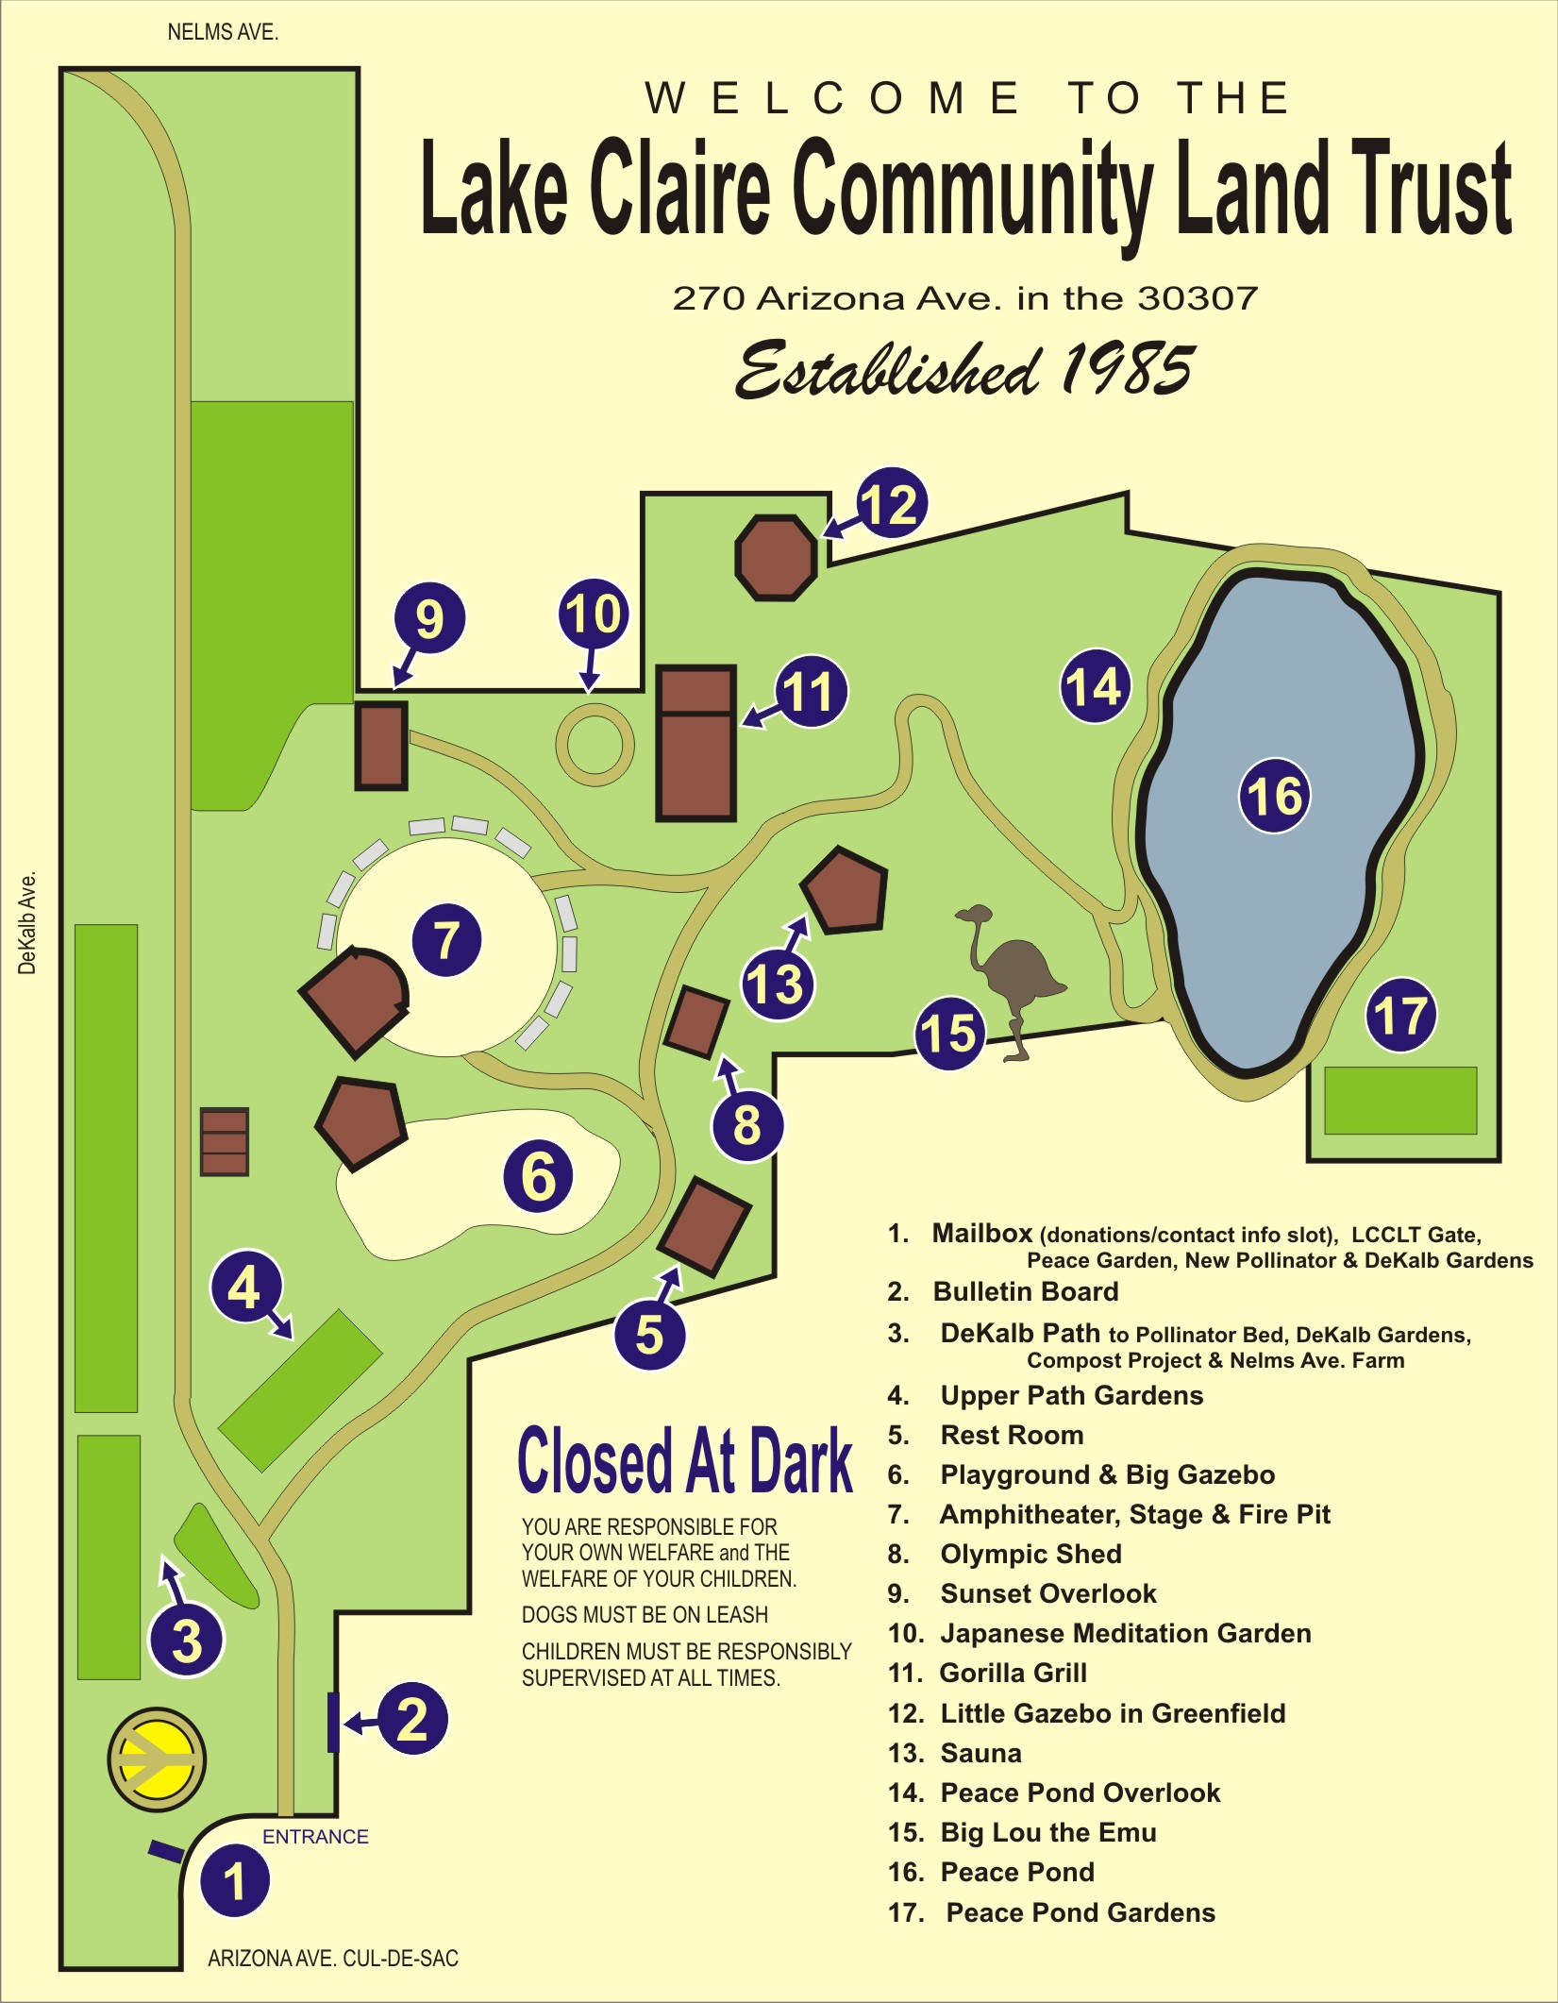

Beginning at 270 Arizona Ave. cul-de-sac entrance
(approx. 35 minutes – follow numbers on map)
1. New LCCLT Gate, designed and built by Bernard Spenle and Julia Hill, Dec. 2015.
Left – Address Mosaic (270 Arizona Ave.) by founding trustee Miriam Herbers, 2016; Mailbox for membership forms and donations as well as U.S. mail. Peace Garden, four beds divided by paths in shape of peace sign; used for Human Peace Sign Vigil on July 4, 2007.
2. Right – Bulletin board, available to the community for posting info and announcements.
See left-hand section (under plexiglass) for Land Trust info. Help yourself to a brochure.
Left – Wood chip pile, donated by tree-removal companies, available to the community in small quantities for free, or by the pickup-load for a nominal donation.
3. Path downhill to left leads to new Pollinator Bed (2016), Dekalb Gardens, wooden Compost Bins from Terra Nova Compost Workshop (2016), an ongoing project; Nelms Ave. Farm and Bee Hives at end of path on right. Farm currently used by “Dads & Uncles” mentoring program for youth. Ongoing project: nontoxic clearing of weeds on Dekalb Ave. embankment (left of path), planting of native grasses/flowers/trees with Trees Atlanta and landscape architect and neighbor Leah Pine; LCCLT still paying for help with weeding & watering until plants are established & new plantings completed.
4. Main Path, right – Well Housing, small wooden structure behind shrubbery; well drilled 500 ft. down into granite substrate (1990, grant from Amoco Foundation thru SouthFace Institute). Left – Path Gardens, revamped in 2015 with anonymous $500 materials donation. Solar Panel powers pump 100 ft. down in well, pumping water to 1600-gallon holding tank to irrigate gardens (see #9). Rain Water Catchment Tower at end of gardens built by Bernard Spenle (May 2013, $1,000 City of Atlanta “Love Your Block” Grant).
5. Right – Restroom, completed 2001, free magazines (donated), LCCLT brochures & calendar postcards available here. Painting inside by Ray Pague, 2016. Bike Rack (grant from the city to NPU-N, one of several placed around the neighborhood by Amy Stout).
6. Left – Playground and Big Gazebo (1993, donation from neighbor Kathy Kennedy); potlucks, annual July 4th Cook-Off, Pumpkin Carving, Easter Egg hunt. Fresh sand added several times a year. Rain Barrels along fence catch water from roof of Stage (#7) to irrigate Dekalb Ave. gardens below (#3).
7. Left – Stage (2002), amphitheater and fire pit; performances, movies, Drum Circles (1st & 3rd Sat. nights each month since 1990), music festival fundraisers, weddings. (Oct. 2013, $1,000 grant from Councilperson N. Archibong’s office thru Lake Claire Neighbors for side wall of amphitheater, stone benches, picnic tables, plantings. Project in progress: replacing fence behind stage (funds raised by neighborhood band Webster, performing on LT stage, May 2016).
8. Right – Olympic Shed, built for 1996 Olympics campground as two-hole outhouse, revamped into storage shed for festival supplies.
9. Left – Sunset Overlook (2008) at highest point on the land with view of downtown skyline, deck built to cover 1600-gallon water tank (2008, Atlanta Girls’ School grant) for gravity-fed irrigation for all gardens. Upper circle; festival vendors, fire performers for Drum Circles.
10. Right – Japanese Meditation Garden (May 2013, also funded by City of Atlanta “Love Your Block” grant); designed by Linda Pace & Brynan Hadaway.
11. Left – Gorilla Grill (April 2007); food & drink service area for events. In winter, heated by small woodstove, also used for neighborhood Friday night jams, classes & meetings. Creative woodworking here, as elsewhere around the Trust, done by founding trustee Charlie Pope. Stained glass by Trevor Degler, interior painting by Sunshine Allard and Buddy McCue.
12. At rear fence – Little Gazebo, included in purchase of Greenfield from neighbor & founding trustee Richard Powers and his wife Joanne Young-Powers.
13. Right (down sloping switchback path) – Sauna; open supervised Sweat ceremonies (Native American tradition filtered through personal spirituality of Robert Pue; for donation); Showers, built in 1996 for Olympic campers using 55-gallon black-painted solar-heated overhead drums. Little Fishpond began as a SouthFace demo (a non-profit energy efficiency org.), later rebuilt with cement (March 2012, $500 grant thru Community Foundation/Gay & Lesbian ATL Fund, in honor of Phillip Rush, used for fencing this area). Beyond are more individual gardens.
14. Left – The Meadow, (purchased in 2008 from neighbors), also called Peace Pond Overlook.
15. Right – Big Lou the Emu (resident since 1993); lives in neighboring yard with two male mallards, Eddie & Aidan; fed twice daily by emu-keeper Dawn Aura. Loves visitors, hates barking dogs, yelling kids, etc. Feed him snacks (grapes, bite-size vegetables & fruit, corn chips). Please leave if you see him getting agitated!
16. Thru gate & across bridge, left – Peace Pond, purchased in 2009 from neighbors and founding trustees Norman Glassman and Marilyn Rosenberg, using $8,000 Community Foundation/Neighborhood Fund’s “Common Good” grant, which also included free consultation with a 501(c)(3) specialist. Barn-shaped building beyond the pond is “Amata” – beloved in Latin (not part of LT). Built by a mason in 1944; since 1976 an intentional community with common space.
17. Right – Pond Gardens, another individual gardens area.

